**PRACTICAL FILE**

**OF**

**WEB BASED PROGRAMMING**

INDEX

|  |  |  |  |  |
| --- | --- | --- | --- | --- |
| S.NO**.** | TOPIC | DATE | REMARKS |  |
| 1. | Write a program to print Hello World! |  |  |  |
| 2. | Write a program to perform sum of a two variable. |  |  |  |
| 3. | Write a program to perform arithmetic operation using arithmetic operator. |  |  |  |
| 4. | Write a program in PHP to show the use of Turnery Operator. |  |  |  |
| 5. | Write a program in PHP to perform Comparison using Comparison Operator. |  |  |  |
| 6. | Write a program in PHP to show the use of Logical operator. |  |  |  |
| 7. | Write a program to show the usage of Assignment Operator. |  |  |  |
| 8. | Write a program in PHP using if and else. |  |  |  |
| 9. | Write a program in PHP using else if. |  |  |  |
| 10. | Create an array and display its content using foreach loop in PHP. |  |  |  |
| 11. | Create an Associative Array using PHP. |  |  |  |
| 12. | Create a multi-dimensional array using PHP. |  |  |  |
| 13. | Write a program in PHP to show the use of foreach and continue statement. |  |  |  |
| 14. | Write a program in PHP to show the use of while loop and break statement. |  |  |  |
| 15. | Write a program to show the usage of DO-WHILE Loop. |  |  |  |
| 16. | Write a program in PHP to perform the increment and decrement in While Loop. |  |  |  |
| 17. | Write a program to showcase the For loop. |  |  |  |
| 18. | Write a program in PHP to perform a function **preg_match_all** in string. |  |  |  |
| 19. | Write a program in PHP to perform a function **ereg_replace** in string. |  |  |  |
| 20. | Write a program in PHP to perform a function **preg_split** in string. |  |  |  |
| 21. | Write a program in PHP to show the use of **preg_replace and str_replace** in string. |  |  |  |
| 22. | Write a program in PHP to perform a function **preg_grep** in string. |  |  |  |
| 23. | Write a program in PHP to showcase the printing of an Indexed array. |  |  |  |
| 24. | Write a program to print the contents of an array in Upper Case. |  |  |  |
| 25. | Write a program to show the use of function array_chunk. |  |  |  |
| 26. | Write a program to perform count() function. |  |  |  |
| 27. | Write a program to perform sorting on array elements. |  |  |  |
| 28. | Write a program in PHP to reverse an array using array_reverse function. |  |  |  |
| 29. | Write a program in PHP to search an element in an array. |  |  |  |
| 30. | Write a program in PHP to intersect a array. |  |  |  |
| 31. | Write a program in PHP to perform a function **preg_match** in string. |  |  |  |
| 32. | Write a program to perform all four types of sorting. |  |  |  |
| 33. | Write a program to validate the form data using Filter_var() function. |  |  |  |
| 34. | Write a program to show the usage of Cookie. |  |  |  |
| 35. | Write a program to show the usage of Session |  |  |  |
| 36. | Write a program to implement oops concepts. |  |  |  |
| 37. | Do Form handling In PHP Design a personal Information form , then Submit & Retrieve the Form Data Using $_GET(), $_POST() and $_REQUEST() Variables |  |  |  |
| 38. | Design A Login Form and Validate that Form using PHP Programming |  |  |  |
| 39. | Create Admin Login ,Logout form using session variables |  |  |  |
| 40. | Write a program to create a file. |  |  |  |
| 41. | Write a program that use various PHP library functions, and that manipulate files and directories. |  |  |  |
| 42. | Write a program to read and display the content of previously created file. |  |  |  |
| 43. | Write a program to modify the content of an existing file. |  |  |  |
| 44. | Create a web page and which provides File uploading and downloading a file. |  |  |  |
| 45. | Design a from which upload And Display Image in PHP |  |  |  |
| 46. | Use phpMyAdmin and perform the following:  import, review data and structure, run SQL statements, create users and privileges |  |  |  |
| 47. | Write a program to create a mysql database. |  |  |  |
| 50. | Write a program to create a table and insert few records into it using form. |  |  |  |
| 51. | Write a program to select all the records and display it in table. |  |  |  |
| 52. | Write a program to modify (delete/modify/add) a table. |  |  |  |
| 53. | Write a PHP script, to check whether the page is called from 'https' or 'http'. |  |  |  |
| 54. | Write a program to verify text data as per the pattern. |  |  |  |
| 55. | Create a dynamic website by incorporating the following functionalities:  • Implement a basic registration and login system, with styling,  • Make the database connection  • Make a connection to a MySQL database, and log in with valid credentials.  • Create Dynamic, interactive and database - Driven web application using php & mysql  • Perform some validation check. If any of these operations cause an error, stop execution and print the error message. The script should respond differently depending on the situation.  Add a “Log Out” button to logout from the system |  |  |  |
|  |  |  |  |  |

**PHP first Program**

Program:-1

<html>

<head>

    <title>Hello Php</title>

</head>

<body>

    <h2>hello PHP</h2>

    <?php

    echo "<br>hello world";

    print("<br>hello php");

    ?>

</body>

</html>

Output:-

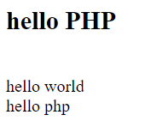

Program:-2 Sum

<?php

    $x = 15;

    $y = 35;

    $z =$x + $y;

    echo "Sum: ".$z;

?>

Output

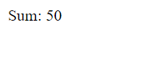

Program:-3 Arithmatic Operator in PHP

<html>

<head>

    <title>Arithmatic Operator</title>

    <style>

        .container{

            max-width: 90%;

            color:white;

            background-color: lightblue;

            padding: 23px;

        }

    </style>

</head>

<body>

<div class="container">

        <h1>Arithmatic Operator in PHP </h1>

        <h1>Learn About PHP & CSS & html </h1>

        CSS in php;

        Lorem ipsum dolor, sit amet consectetur fugit architecto ;<br>

    <?php

        echo "<br>" ;

        echo "<h1> 😎 hello World 😜</h1>";

        echo "😎 hello PHP <br>";

        echo "<br>";

        $a =10;

        $b =20;

        $c = $a+$b;

        echo "Addition Operation Result:$a+$b = $c <br>";

        $c = $a-$b;

        echo "Substraction Operation Result:$a-$b = $c <br>";

        $c = $a*$b;

        echo "Multiplication Operation Result:$a*$b = $c <br>";

        $c = $a/$b;

        echo "Division Operation Result:$a/$b = $c <br>";

        $c = $a%$b;

        echo "Modulus Operation Result:$a%$b = $c <br>";

        print("a=10 <br>");

        $c = $a++;

        echo "Increment Operation Result: $c <br>";

        $c = $a--;

        echo "Decrement Operation Result: $c <br>";

        ?>

    </div>

</body>

</html>

Output:-

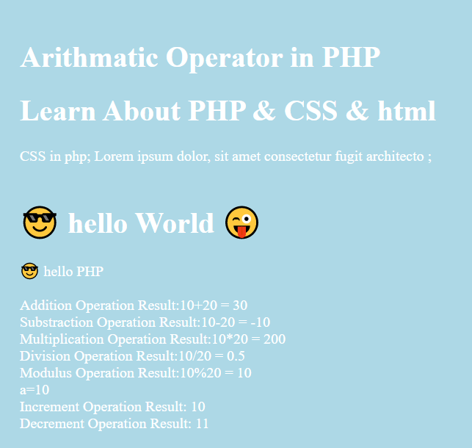

Program:-4 Arithmetic Operator in PHP

<html>

<head>

    <title>Assignment Operator</title>

    <style>

        .container{

            max-width: 90%;

            color: white;

            background-color: blue;

            padding: 23px;

        }

    </style>

</head>

<body>

    <div class="container">

        <h1>Assignment Operator in PHP </h1>

        <?php

          echo "<br>a = ".$a=10;

          echo "<br>b = ".$b=30;

          echo "<br>";

            $c= $a+$b;     //Assignment Operator

            echo "Addition Operator result : $c<br/>";

            $c += $a;

            echo "Add and Assignment Operator result : $c<br/>";

            $c -= $a;

            echo "Subtract and Assignment Operator result : $c<br/>";

            $c *= $a;

            echo "Multiply and Assignment Operator result : $c<br/>";

            $c /= $a;

            echo "Division and Assignment Operator result : $c<br/>";

            $c %= $a;

            echo "Modulus and Assignment Operator result : $c<br/>";

        ?>

    </div>

</body></html>

Output:-

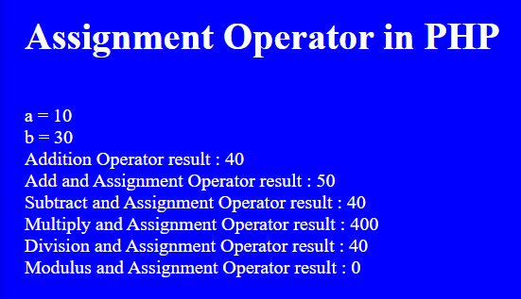

Program:-5 if , else ,else if with date function

<?php

    $d= date("D");

    if($d=="Sat")

    {

        echo "Have a nice Weekend! ";

    }

    else{

        echo "Have a nice day! ";

    }

?>

<br><br><br>

<?php

    $d= date("D");

    if($d=="Sat")

        echo "Have a nice Weekend! ";

    elseif($d=="Sun")

        echo "Have a nice Sunday! ";

    else

        echo "Have nice day! ";

?>

Output:-

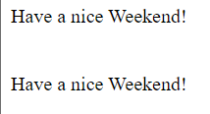

Program:-6 Conditional Statement in PHP

<html>

<head>

    <title> Conditional Statment</title>

</head>

<body>

    <h2>Conditional Statment</h2>

    <?php

    echo "a = ".$a=10;

    echo "<br>b = ".$b=30;

    echo "<br>";

    $result  = ($a>$b)?$a:$b;

    echo "Test : value of Result is $result<br>";

    $result  = ($a<$b)?$a:$b;

    echo "Test : value of Result is $result<br/>";

    ?>

</body>

</html>

Output:-

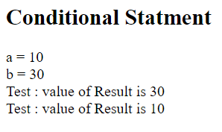

Program:- 7 Logical Operator in PHP

<html>

<head>

    <title>Logical Operator</title>

</head>

<body>

<h2>Logical Operator</h2>

<?php

    $a=33;

    $b=0;

    if($a && $b){

        echo "TEST1 : Both a and b are true <br/>";

    }else{

        echo "TEST1 : Either a and b are false <br/>";

    }

    if($a and $b){

        echo "TEST2 : Both a and b are true <br/>";

    }else{

        echo "TEST2 : Either a and b are false <br/>";

    }

    if($a || $b){

        echo "TEST3 :Either a and b are true <br/>";

    }else{

        echo "TEST3 : Both a and b are false <br/>";

    }

    if($a or $b){

        echo "TEST4 :Either a and b are true <br/>";

    }else{

        echo "TEST4 : Both a and b are false <br/>";

    }

    $a = 10;

    $b=20;

    if($a){

        echo "TEST5 : a is true <br/>";

    }else{

        echo "TEST5 : a is false <br/>";

    }

    if($b){

        echo "TEST6 : b is true <br/>";

    }else{

        echo "TEST6 : b is false <br/>";

    }

    if(!$a){

        echo "TEST5 : a is true <br/>";

    }else{

        echo "TEST5 : a is false <br/>";

    }

    if(!$b){

        echo "TEST6 : b is true <br/>";

    }else{

        echo "TEST6 : b is false <br/>";

    }

        ?>

</body>

</html>

Output:-

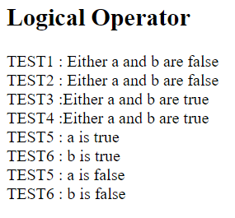

Program:- 8 Comparison operator in PHP

<?php

echo "<b>Comparison Operators<b><br>";

$a=42;

$b=20;

if($a==$b)

{

    echo "TEST1: a is equal to b<br/>";

}

else{

    echo "TEST1: a is not equal to b<br/>";

}

if($a>$b)

{

    echo "TEST2: a is greater than b<br/>";

}

else{

    echo "TEST2: a is not greater than b<br/>";

}

if($a<$b)

{

    echo "TEST3: a is less than b<br/>";

}

else{

    echo "TEST3: a is not less than b<br/>";

}

if($a!=$b)

{

    echo "TEST4: a is not equal to b<br/>";

}

else {

    echo "TEST4: a is equal to b<br/>";

}

if($a>=$b)

{

    echo "TEST5: a is either greater than or equal to b<br/>";

}

else{

    echo "TEST5: a is neither greater than nor equal to b<br/>";

    }

if($a<=$b)

{

    echo "TEST6: a is either less than or equal to b<br/>";

}

else{

    echo "TEST6: a is neither less than nor equal to b<br/>";

    }

?>

Output

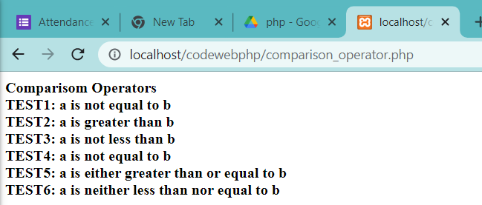

Program:- 9

<?php

echo "<b>😎 By Use Date function😎<b><br/>";

$d=date("D");

if($d=="Sat")

echo "Have a nice weekend!";

elseif($d=="Sun")

echo "Have a nice Sunday!";

else

echo "Have a nice day!";

?>

OUTPUT:-

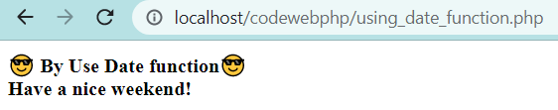

Program:- 10

<?php

echo "<b>🚀Array in php🚀<b><br/>";

$number=array(1,2,"Shehbaz",4,5);

foreach($number as $value)

{ echo "value is $value<br/>"; }

?>

OUTPUT:-

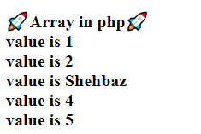

Program:- 11

<?php

echo "<b>🚀Array in php🚀<b><br/>";

$salaries=array("Mohammad"=>2000,"Qadir"=>1000,"Zara"=>500);

echo "Salary of Mohammad ".$salaries['Mohammad']."<br/>";

echo "Salary of Qadir ".$salaries['Qadir']."<br/>";

echo "Salary of Zara ".$salaries['Zara']."<br/>";

?>

OUTPUT:-

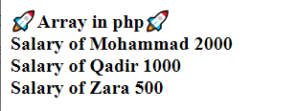

Program:- 12

<?php

echo "<b>🚀Multi--Array in php🚀<b><br/>";

$marks=array("Mohammad"=>array("Physics"=>35,"Maths"=>30,"Chemistry"=>39),"Qadir"=>array("Physics"=>30,"Maths"=>32,"Chemistry"=>27),"Zara"=>array("Physics"=>31,"Maths"=>22,"Chemistry"=>39));

echo "Marks for Mohammad in Physics:";

echo $marks['Mohammad']['Physics']."<br/>";

echo "Marks for Qadir in Maths:";

echo $marks['Qadir']['Maths']."<br/>";

echo "Marks for Zara in Chemistry:";

echo $marks['Zara']['Chemistry']."<br/>";

?>

OUTPUT:-

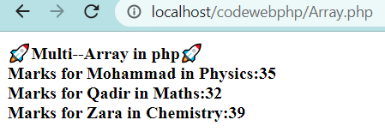

Program:- 13

<?php

print("<b>🚁Continue Statement.🚁<b><br/>");

$array=array(1,2,3,"hello",4,true);

foreach($array as $value)

{

    if($value==3)

    continue;

    echo "Value is $value <br/>";

}

?>

OUTPUT:-

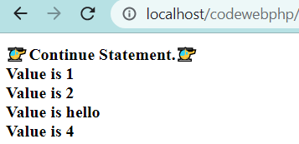

Program:- 14

<?php

echo "<b>🍺break statement in while loop🍺<b><t><\n>";

$a=0;

while($a<10)

{

    $a++;

    echo "hello ".$a."<br/>";

    if($a==5)

    break ;

}

echo"Loop stopped at a = $a";

?>

OUTPUT:-

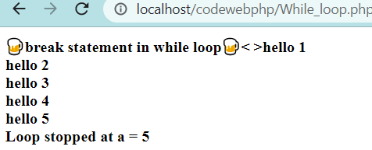

Program:- 15

<?php

echo "<b>🍺DO while loop🍺<b><t><\n>";

$a=1;

do{

    echo "hello ".$a."<br/>";

    ++$a;

}while($a<=10);

echo"Loop stopped at a = $a";

?>

OUTPUT:-

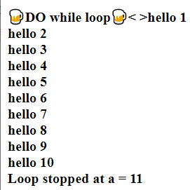

Program:- 16

<?php

echo "<b>🍺 While loop 🍺<b><br/>";

$i=0;

$num=50;

while($i<10)

{

    $num--;

    $i++;

}

echo "Loop stopped at i = $i and num = $num";

?>

OUTPUT:-

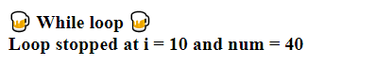

Program:- 17

<?php

echo "<b>🍺 For loop 🍺<b><br/>";

$b =10;

for($a=1;$a<10;$a++){

    echo "hello for loop a = $a<br/>";

    $b--;

}

echo "value of b = $b<br/>";

?>

OUTPUT:-

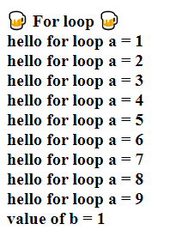

Program:- 18

<?php

echo "<b>🍧🍦Search string to have a-z and A-Z🍭🍡<b><br/> ";

echo "<b>🍭🍡By using regex and preg_match🍧🍦<br/>";

$regex='/^[a-zA-Z ]*$/';

$nameString='Shahrukh Khan';

if(preg_match($regex,$nameString)){

    echo("Name string matching with"." regular expression");

}

else{

    echo("Only letters and white space"." allowed in name string");

}

?>

OUTPUT:-

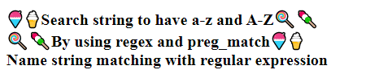

Program:- 19

<?php

echo "<b>🍧🍦Search string to have Match pattern <b>(.*)<\/b> 🍭🍡<b><br/> ";

echo "<b>🍭🍡By using regex and preg_match_all🍧🍦<br/>";

$regex="/<b>(.*)<\/b>/U";

$inputString="name: <b>John</b> Position: <b>Developer</b>";

preg_match_all($regex,$inputString,$output);

echo $output[0][0]."<br/>".$output[0][1]."\n";

?>

OUTPUT:-

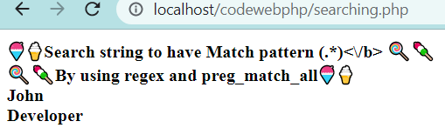

Program:- 20

<?php

echo "<b>🍧🍦  Search string to have Match pattern [0-9]+  🍭🍡<b><br/> ";

echo "<b>🍭🍡 function ereg_replace(replace string)<b> 🍭🍡<br/>";

echo "<b>🍭🍡 By using regex and ereg_replace 🍧🍦<br/>";

$regex="([0-9]+)";

$original="Completed graduation in 2004";

$replacewith="2002";

$original=preg_replace($regex,$replacewith,$original);

echo $original;

?>

OUTPUT:-

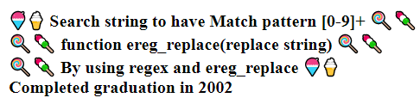

Program:- 21

<?php

echo "The preg_split() function_ breaks a string_ into an array_ <br/>" ;

echo "using matches of a regular expression as separators.<br/>";

$ip="134.645.478.670";

$regex="/\./";

$output=preg_split($regex,$ip);

echo "$output[0] <br>";

echo "$output[1] <br>";

echo "$output[2] <br>";

echo "$output[3] <br>";

?>

OUTPUT:-

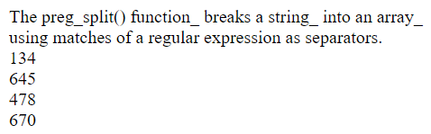

Program:- 22

<?php

echo "<b>🍧🍦  Search string to Match pattern /\s/  🍭🍡<b><br/> ";

echo "<b>🍭🍡 function preg_replace(replace string)<b> 🍭🍡<br/>";

echo "<b>🍭🍡 By using pattern and preg_replace 🍧🍦<br/>";

$pattern="/\s/";

$replacement="-";

$text="Earth revolves around\nthe\tSun";

echo preg_replace($pattern,$replacement,$text);

echo "<br>";

echo str_replace(" ","-",$text);

?>

OUTPUT:-

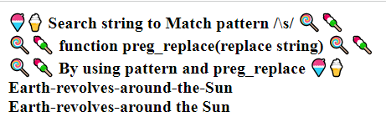

Program:- 23

<?php

$pattern="/^J/";

$names=array("John Abraham","Shehbaz","John Puneet");

$matches=preg_grep($pattern,$names);

foreach($matches as $match){

    echo $match."<br>";

}

?>

OUTPUT:-

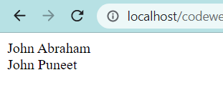

Program:- 24

<?php

$season=array("summer","winter","spring","autumn");

echo "Season are: $season[0],$season[1],$season[2] and $season[3]";

?>

OUTPUT:-

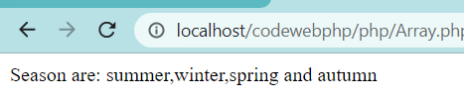

Program:- 25

<?php

$salary=array("Sonoo"=>"550000","Vimal"=>"250000","Ratan"=>"200000");

print_r(array_change_key_case($salary,CASE_UPPER));

?>

OUTPUT:-

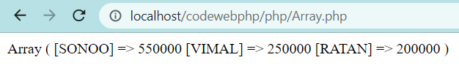

Program:- 26

<?php

$salary=array("Sonoo"=>"550000","Vimal"=>"250000","Ratan"=>"200000");

print_r(array_chunk($salary,2));

?>

OUTPUT:-

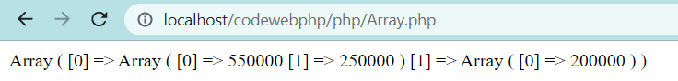

Program:- 27

<?php

echo "<b>🧊 Count function use for count Array elements  🧊<b><br/>";

echo "print number of elenents<br/>";

echo "number of Array elements is = ";

$season=array("summer","winter","spring","autumn");

echo count($season);

?>

OUTPUT:-

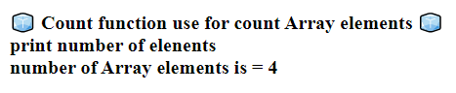

Program:- 28

<?php

echo "<b>🧊 Sort array with respect to alphabet 🧊<b><br/>";

$season=array("summer","winter","spring","autumn");

sort($season);

foreach($season as $s)

{

    echo "$s<br/>";

}

?>

OUTPUT:-

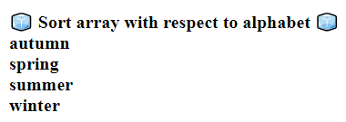

Program:- 29

<?php

echo "🧊 print Array in reverse order 🧊<br/>";

$season=array("summer","winter","spring","autumn");

$reverseseason=array_reverse($season);

foreach($reverseseason as $s)

{

    echo  "$s<br/> ";

}

?>

OUTPUT:-

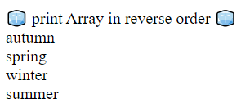

Program:- 30

<?php

echo "🧊 find array element have spring or not 🧊 <br/> ";

echo "🧊 if Array have string then print index number 🧊 <br/> ";

echo "Array index = ";

$season=array("summer","winter","spring","autumn");

$key=array_search("spring",$season);

echo $key;

?>

OUTPUT:-

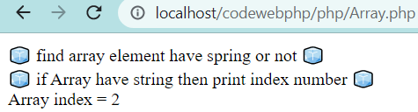

Program:- 31

<?php

echo "🎖️🎖️Array intersect function use for check intersection 🎖️<br/>";

echo "🎖️🎖️of selected Array then print intersection element 🎖️<br/>";

$name1=array("The great INDIAN NAVY","john","vivek","The great INDIAN ARMY");

$name2=array("umesh","The great INDIAN NAVY", "The great INDIAN ARMY");

$name3=array_intersect($name1,$name2);

foreach($name3 as $n)

{

    echo "$n<br/>";

}

?>

OUTPUT:-

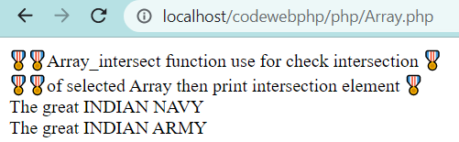

Program:- 32

<?php

$x=4;

function assign()

{

    $x=0;

    print"\ $x inside function is $x";

}

assign();

print"\ $x outside function is $x ";

?>

OUTPUT: -

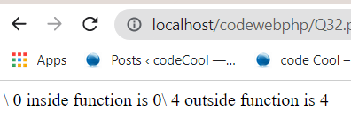

Program:- 33

<?php

$some=15;

function addit()

{

    GLOBAL $some;

    $some++;

    print"some is $some";

}

addit()

?>

OUTPUT: -

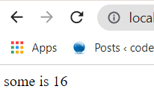

Program: - 34

<?php

function track ()

{STATIC $count =0;

$count++;

print $count ;

print "";

}

track();

track();

track();

OUTPUT: -



Program: - 35

<?php

$array=array("Ram","Krishna","Aakash","Guarav","Raghav");

print_r(array_slice($array,1,3,true));

?>

OUTPUT: -

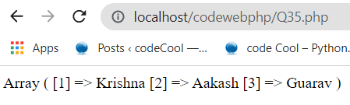

Program: - 36

<?php

// PHP function to illustrate the use of array_pad()

 function Padding ($array, $string)

{

$result=array_pad($array, 7, $string);

return($result);

}

$array=array("one", "two", "three", "four", "five");

$string="six";

print_r(Padding ($array, $string));

?>

OUTPUT: -

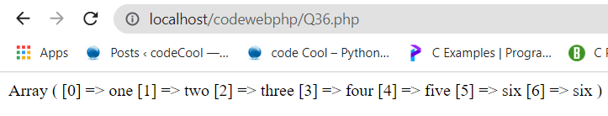

Program: - 37

<?php

// PHP function to illustrate the use of array_pad()

 function Padding ($array, $string)

{

$result=array_pad($array,-7, $string);

return($result);

}

$array=array("one", "two", "three", "four", "five");

$string="six";

print_r(Padding ($array, $string));

?>

OUTPUT: -

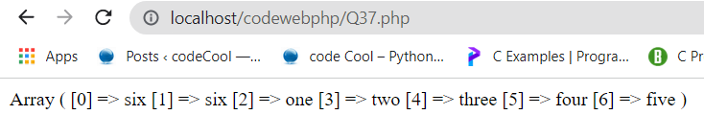

Program: - 38

<html>🧐🧐🧐🧐

<body>

<?php

echo "Return 5 elements and insert a value of <br/>"  ;

echo "blue to the new elements in the array: <br/>";

echo "if length of array in negative add value(blue) in starting <br/>";

$a=array("red","green");

print_r(array_pad($a,5,"blue"));

?>

</body>

</html>

OUTPUT: -

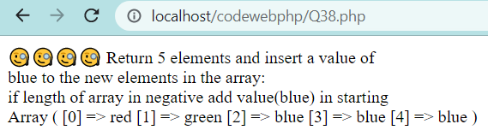

Program: - 39

<?php

// PHP program to illustrate the use

// of array_splice() function

$array1=array("10" =>"raghav ", "20"=>"ram", "30"=>" aakash ","50"=>"ravi") ;

$array2 = array("60"=>"ankita", "70"=>"antara") ;

echo "The returned array: \n";

print_r(array_splice($array1, 1, 4, $array2));

echo "\nThe original array is modified to: \n";

print_r($array1);

?>

OUTPUT: -



Program: - 40

<?php

// PHP program to demonstrate the

// use of list() function

$array = array(5, 6, 2, 4);

// Assign array values to variables

list ($a, $b, $c) = $array;

echo "a =", ($a), "\n";

echo "b =", ($b), "\n";

echo "c =", ($c), "\n";

echo "a*b*c =", ($a*$b*$c);

?>

OUTPUT: -

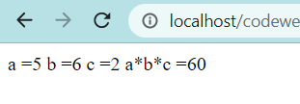

Program: - 41

<?php

// PHP program to demonstrate assignment of // particular index values in the array to

// variables.

$array=array(1, 2, 3, 4);

// Assign array values to variables

list(, ,$a)=$array;

// Print all assigned values

echo" a = ", ($a), "\n";

?>

OUTPUT: -

Program: - 42

<?php

$a=readline('Enter a value: ');

echo $a;

$b=readline(' <br/> Enter a value: ');

$sum=$a+$b;

echo $sum;

?>

OUTPUT: -

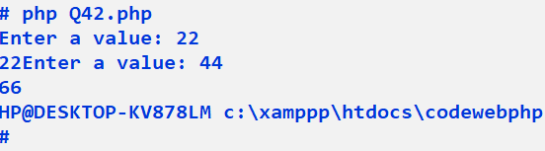

Program: - 43

<?php

$a= 10;

$a= (int)readline('Enter an Integer');

$b= 9.78;

 $b= (float)readline('Entered a Floating'.'point number');

 echo "Entered integer is: $a". "and entered float is:$b";

?>

OUTPUT: -

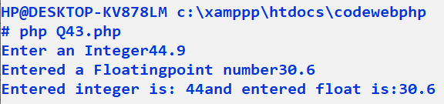

Program: - 44

<html>

<head>

<title>Writing PhP Function</title>

</head>

<body>

<?php

function Writemessage()

{

echo "You are really nice person";

}

Writemessage();

?>

</body>

</html>

OUTPUT: -

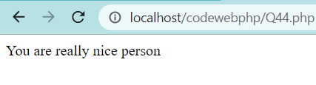

Program: - 45

<?php

 function addfunction($num1, $num2)

{

$sum=$num1+$num2;

echo "Sum of the two numbers is: $sum";

}

 addfunction (1000, 2000);

?>

OUTPUT: -

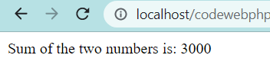

Program: - 46

<?php

function print_string($string)

{

$string="Function is running"."\n"."<br/>";

print ($string);

}

$string="Global Data"."\n";

print_string($string);

print ($string);

?>

OUTPUT:

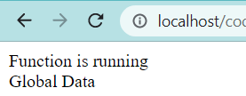

Program: - 47

🧐🧐🧐

<?php

function print_string(&$string)

{

$string="Function is running"."\n"."<br/>";

print ($string);

}

$string="Global Data"."\n";

print_string($string);

print ($string);

?>

OUTPUT: -

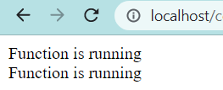

Program: - 48

<?php

function addfun($num1,$num2)

{

    $sum=$num1+$num2;

    return $sum;

}

$return_value=addfun(10,20);

echo "returns value from the function : $return_value";

?>

OUTPUT: -

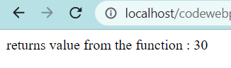

Program: - 49

<?php

function sayhello()

{

    echo"Hello<br/>";

}

$function_holder="sayhello";

$function_holder();

?>

OUTPUT: -

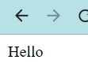

Program: - 50

<?php

$flag = 0;

echo "Program check num is prime or not :";

$num = (float)readline("Enter number  ");

for ($i = 2; $i < $num; $i++) {

    if ($num % $i == 0) {

        $flag = 1;

    }

}

if ($flag == 1) {

    print("not a prime number  $num ");

} else {

    print("$num Is prime number ");

}

?>

OUTPUT: -

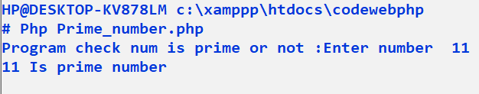

Program: - 51

<?php

     if(isset($_POST["name"]))

    {

        echo "Welcome " .$_POST['name']."<br/>";

    }

    if(isset($_POST["age"])){

        echo "you are ".$_POST['age']."years old";

        exit();

    }

?>

<!DOCTYPE html>

<html lang="en">

<body>

    <form action="<?php $_PHP_SELF ?>" method="POST">

    name: <input type="text" name="name" />

    Age: <input type="text" name="age" />

    <input type="Submit" />

    </form>

</body>

</html>

OUTPUT: -

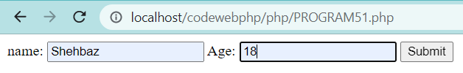

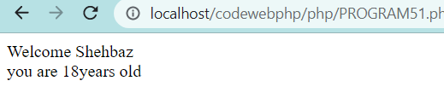

Program: - 52

<?php

    setcookie("name","jhon",time()+1*60*60,"/","",0);

    setcookie("Age","34",time()+1*60*60,"/","",0);

?>

<html>

<head>

    <title>SET cookies</title>

</head>

<body>

    <?php

    echo "Set cookies";

    ?>

    <p><?= "Hello world!" ?></p>

</body>

</html>

OUTPUT: -

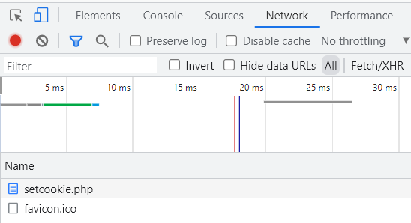

Program: - 53

<?php

    session_start();

    if(isset($_SESSION['Counter']))

    {

        $_SESSION['counter']+= 1;

    }

    else{

        $_SESSION['counter'] = 1;

    }

    $mag = "you have visited this page ".$_SESSION['counter'];

    $mag. "in this Session" ;

    ?>

<html>

<head>

    <title>Session </title>

</head>

<body>

    <?php

    echo ($mag);

    ?>

</body>

</html>

OUTPUT: -

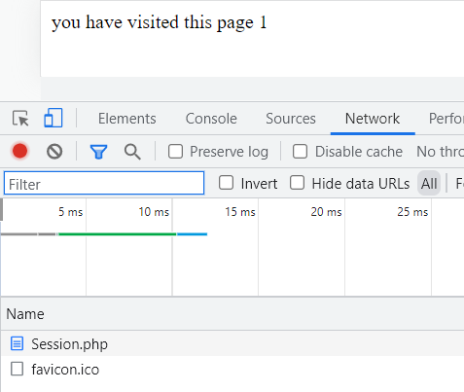

Program: - 54

<html>

<head>

    <title>Accessing cookies</title>

</head>

<body>

    <?php

    echo $_COOKIE["name"]."<br>";

    echo $_COOKIE["Age"]."<br>";

    // echo $_HTTPS_COOKIE_VARS["Age"]."<br>";

    ?>

</body>

</html>

OUTPUT: -

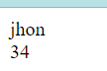

Program: - 55

<html>

<head>

    <title>Cookie isset</title>

</head>

<body>

    <?php

    if(isset($_COOKIE["name"])){

        echo "Welcome ".$_COOKIE["name"]."<br>";

    }else

    {

        echo "Sorry --- not Recognized"."<br/>";

    }

    ?>

</body>

</html>

Output:-



Program: - 56

<?php

$filename = "D:\hello.txt";

$file  = fopen($filename,"w");

if($file == false){

    echo "Error in Opening new file ";

    exit();

}

fwrite($file,"this is Simple test Php file \n");

fclose($file);

?>

OUTPUT: -

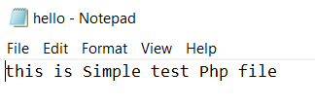

Program: - 57

<html>

<head>

    <title>Image in PHP</title>

</head>

<body>

    <?php

    srand(microtime()*1000000);

    $num = rand(1,4);

    switch ($num) {

        case 1:

            $image_file = "https://cdn.visordown.com/styles/amp_1200/s3/field/image/2018_YAM_MT07_EU_DPBMC_STU_001_03_0.jpg?itok=1Uh42HSK";

            break;

        case 2:

            $image_file = "https://wallpaperaccess.com/full/13647.jpg";

            break;

        case 3:

            $image_file = "https://ai-s1.infcdn.net/screenshots_siandroid/1/16684/16684005_1.jpg";

            break;

        case 4:

            $image_file = "https://cdn.visordown.com/styles/amp_1200/s3/field/image/2018_YAM_MT07_EU_DPBMC_STU_001_03_0.jpg?itok=1Uh42HSK";

            break;

        default:

            echo "null no image ";

            break;

    }

    echo "Random Image: <img src =$image_file >";

    ?>

</body>

</html>

OUTPUT: -

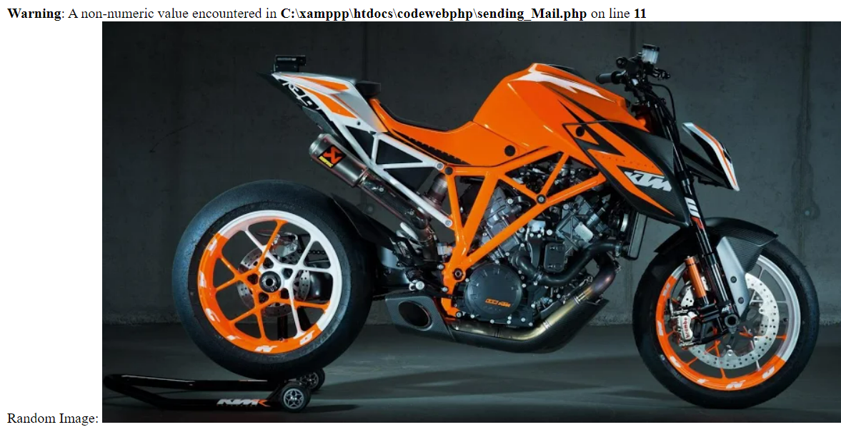

Program: - 58

<?php

echo "warning Error";

include("External_file.php");

?>

OUTPUT: -



Program: - 59

<?php

$a = "Defined error";

echo "Notice error";

echo $b;

?>

OUTPUT: -



Program: - 60

<?php

echo "Red";

echo "Blue";

echo "Green"

?>

OUTPUT: -



Program: - 61

<?php

function sub()

{

    $sub= 6-1;

    echo "The sub = ".$sub;

}

div();

?>

OUTPUT: -



Program: - 62

<?php

$String1 = "This is string in Php";

echo "<br/>";

echo $String1;

echo "<br/>";

$variable = "Name";

$label = 'My $varible will not print';

print($label);

echo "<br/>";

$label = "My $variable  will not print";

print ($label);

?>

OUTPUT: -

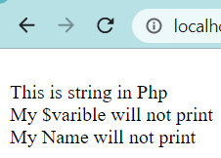

Program: - 63

<?php

$String1 = "This is string in Php <br/>";

$String2 = "hello string in Php <br/>";

echo strlen($String1);

echo "<br/>";

echo strpos($String1,"is");

echo "<br/>";

echo $String1." ".$String2;

?>

OUTPUT: -

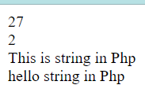

Program: - 64

<?php

    if(!file_exists("D:\hello.txt")){

        die("File not found ");

    }

    else{

        $file = fopen("D:\hello.txt","r");

        print "Open fill successfully";

    }

?>

OUTPUT: -



Program: - 65

<?php

$date_array = getdate();

foreach($date_array as $key=>$val){

    print("$key = $val <br/>");

}

$fomated_date = "today's date : ";

$fomated_date.= $date_array[Mday]."/";

$fomated_date.= $date_array[mon]."/";

$fomated_date.= $date_array[year]."/";

print $fomated_date;

?>

OUTPUT: -

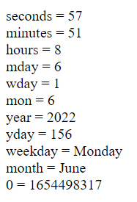

Program: - 66

<?php

    print date("m/d/y G.i:S<br>" , time());

    print "tihs is ";

    print date("j of F y , \a\\t gi a",time());

?>

OUTPUT: -

